Discover Brightwater habitat improvement works River Skerne,
Fishburn to Holdforth Bridge.
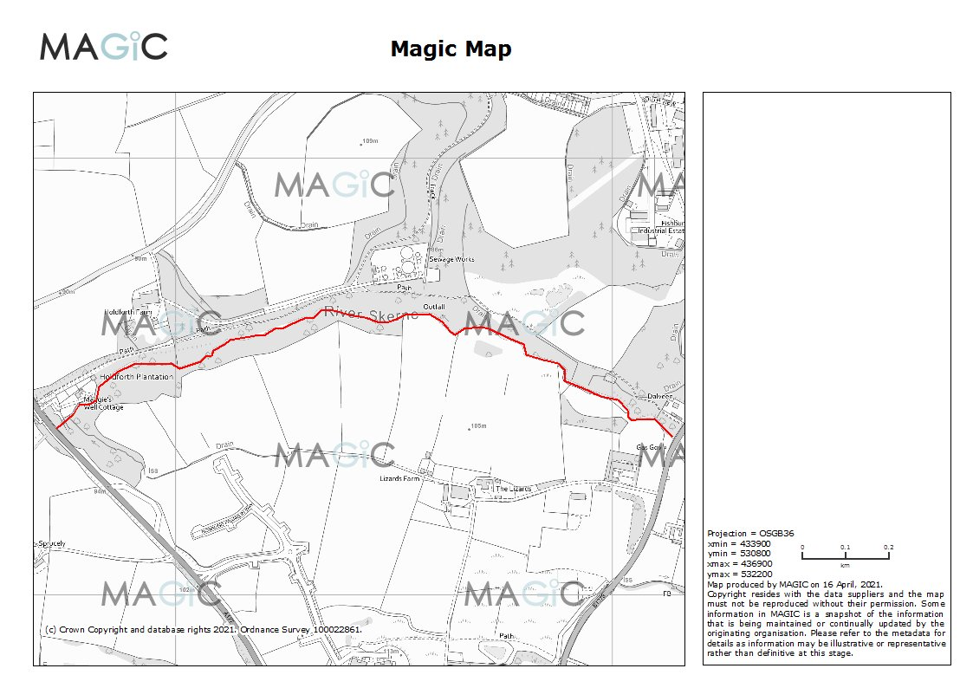

The section of the River Skerne planned for habitat improvement works, is located to the north of Sedgefield. The section of river is located between the A177 from NGR: NZ 34723 31378 upstream to the B1278 salters lane at NGR: NZ 36144 31363.

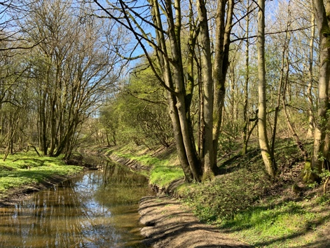

The River along this section has been modified historically through being straightened and engineered. Habitat diversity is generally poor with lack of in-river features, flow dynamics poor bed substrate being heavily silted in areas and heavily over shaded.

Proposed works. See map and attached spread sheet for locations..
There are a number of suitable interventions to help to improve the river through this section, these are:
- Introduction of flow deflectors.
To be constructed from sections of timber sourced on site cut to length and anchored in place using re bar anchor pins, ( as previously used on other sections of the Skerne). Either installed in pairs or in a staggered pattern through listed sections. Design as per river restoration manual.

- Introduction of large woody debris, anchored and pinned as required.
Utilising trees growing over and alongside the river for material.
- Canopy thinning section is heavily over shaded and would benefit from a canopy thin.
- Re profiling of sections of bank , big sections of the river are very incised with steep bank faces, re- profiling to a more gentle slope <45’ / marginal shelf formation.

Map shown below, attached spread sheet shows detail.

9
8
7
6
5
4
3
2
1

